Flavour fusion AI-Driven Recipe Blogging Final Report

1. INTRODUCTION

1.1 Project Overview

Flavour Fusion is an AI-powered recipe blogging web application that generates creative and detailed recipe blogs using Google’s Gemini 1.5 Flash generative AI model. The application allows users to input a recipe topic and desired word count, and the AI generates a structured blog post including ingredients, preparation steps, cooking tips, and conclusion. The application is built using Stream lit for the frontend and Google Generative AI for the backend.

1.2 Purpose

The purpose of Flavour Fusion is to help food bloggers, cooking enthusiasts, and content creators generate high-quality recipe blogs quickly and efficiently using AI. It reduces manual effort and provides instant creative content tailored to user requirements.

2. IDEATION PHASE

2.1 Problem Statement

Food bloggers and content creators often spend significant time writing detailed recipe blogs. This process can be time-consuming and requires creativity, structure, and consistency. Many users need a faster way to generate engaging recipe content.

2.2 Empathy Map Canvas

Users Feel:

Time pressure to create content

Need for creative inspiration

Users Think:

Writing blogs takes too long

AI can help automate content creation

Users Say:

I need quick recipe blog ideas

I want structured and engaging content

Users Do:

Search for recipes online

Write blogs manually

2.3 Brainstorming

Possible solutions:

AI-based recipe generator

Automatic blog writing system

Recipe suggestion engine

Content automation using Generative AI

Final Solution Selected:
AI-powered recipe blog generator using Gemini AI

3. REQUIREMENT ANALYSIS
3.1 Customer Journey Map

User opens Flavour Fusion App
↓
User enters recipe topic and word count
↓
System sends request to Gemini AI
↓
AI generates recipe blog
↓
User views and copies the generated blog
3.2 Solution Requirements
Functional Requirements
- User enters recipe topic
- User selects word count
- AI generates recipe blog
- Display programmer joke while generating
- Display generated blog
Non-Functional Requirements
- Fast response time
- Easy user interface
- Secure API integration
- Scalable cloud deployment
3.3 Data Flow Diagram
User → Stream lit UI → Gemini 1.5 Flash Model → Generated Recipe Blog → User Interface

3.4 Technology Stack

Frontend:

Stream lit

Backend:

Google Generative AI (Gemini 1.5 Flash)

Programming Language:

Python

Libraries:

Stream lit

google-generative ai

random

Deployment:

Localhost / Stream lit Cloud / Google Cloud

4. PROJECT DESIGN
4.1 Problem Solution Fit

The application solves the problem of manual recipe blog writing by automating content generation using AI. It saves time and improves productivity for bloggers.
4.2 Proposed Solution
Flavour Fusion uses Google Gemini AI to generate structured and engaging recipe blogs. The user enters input parameters, and the AI produces detailed content instantly.
4.3 Solution Architecture
Architecture Flow: User Interface (Stream lit)
↓
Backend Processing (Python)
↓
Gemini 1.5 Flash AI Model
↓
Generated Recipe Blog
↓
Display to User

5. PROJECT PLANNING & SCHEDULING
5.1 Project Planning

Phase 1: Requirement Analysis
Phase 2: UI Development using Stream lit
Phase 3: Gemini API Integration
Phase 4: Testing and Debugging
Phase 5: Deployment

Development Methodology:
Agile Model

6. FUNCTIONAL AND PERFORMANCE TESTING
6.1 Performance Testing
Test Case 1:
Input: Vegan Chocolate Cake
Output: Recipe blog generated successfully
Test Case 2:
Input: Gluten Free Bread
Output: Recipe blog generated successfully
Test Case 3:
Invalid Input: Empty topic
Output: Warning message displayed

7. RESULTS

7.1 Output Screenshots
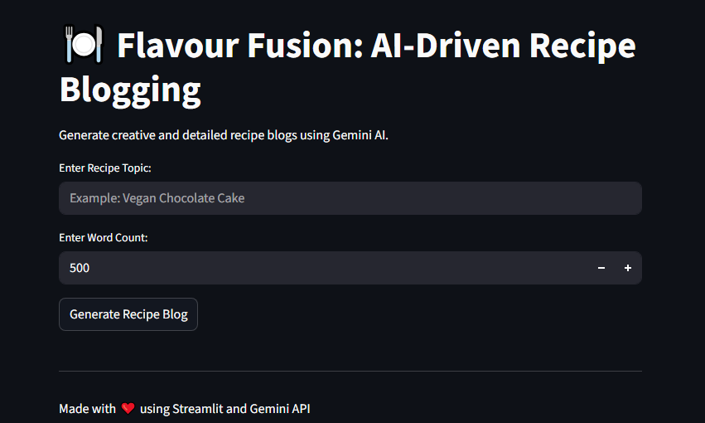

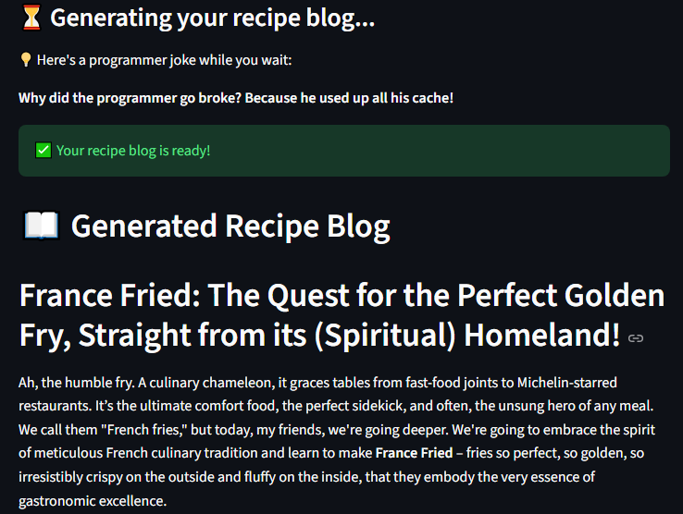



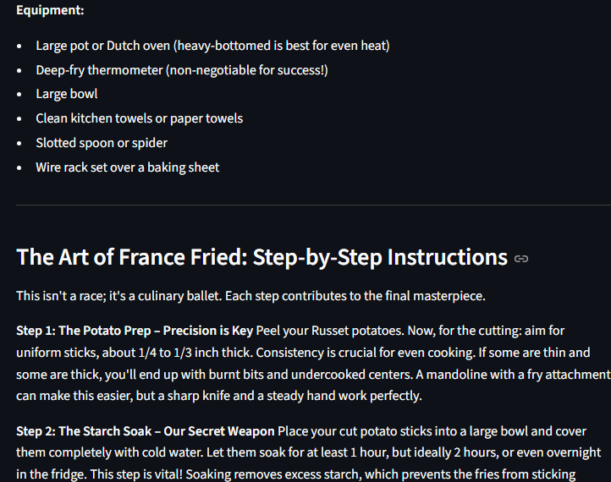
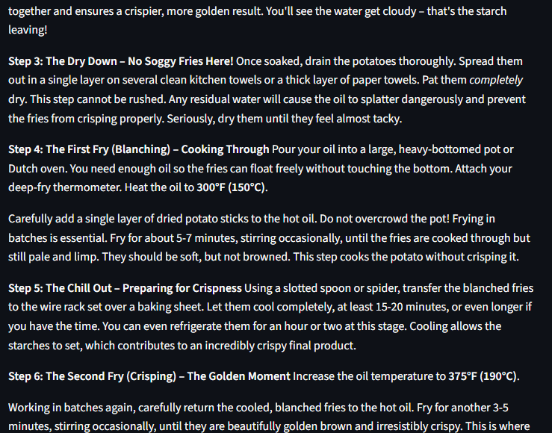

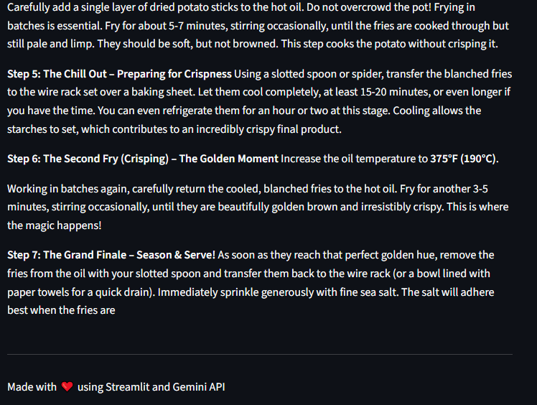

8. ADVANTAGES & DISADVANTAGES

Advantages

Saves time in content creation

Generates creative and structured blogs

Easy to use interface

Fast response time

Automated content generation

Disadvantages

Requires internet connection

Depends on API availability

API usage limits may apply

9. CONCLUSION
Flavour Fusion successfully demonstrates the use of Generative AI for automated recipe blog generation. The application provides an efficient and intelligent solution for content creators. It integrates Streamlit with Google Gemini AI to generate high-quality content quickly and accurately. The project showcases the practical application of cloud-based AI systems.

10. FUTURE SCOPE

Future improvements may include:

Multi-language support

Voice input support

Image generation for recipes

Cloud deployment on Google Cloud

User account system

Blog export to PDF or Word

11. APPENDIX
GitHub link: https://github.com/Abhishek-223/Flavour-Fusion-AI-Driven-Recipe-Blogging
Demo Public link: https://3805-34-125-155-0.ngrok-free.app/

